**Subscription Business Model Definition & Implementation for PowerX**

**(A global power sports and adventure vehicle manufacturer)**



**Background**

PowerX is a one of the leading global manufacturer of power sports and adventure vehicles including off-road all-terrain vehicles, snow mobiles, super bikes, boats, defense vehicles and associated parts and accessories. PowerX operates across 75+ countries with 10000+ employees globally, and sells 20+ vehicle brands in the segment accounting for about 25% of global power sports industry market share.

Their current business model is very traditional in nature, typical of any automotive OEM, focusing on Research, Product Development & Design, Manufacturing, Sales and Service. Their sales and service in managed through a network of dealers spread across the breadth of the country.

**Problem**

Owning the power sports vehicles is a luxury for most of the customers as they are rarely used only during holidays, but cost to the upwards of $25,000 -$30,000 and storing & maintaining them is also an expensive affair.

Customers in the proximity of metro areas choose other entertainment options over Power sports as they face multiple challenges in getting access to the Power sports experience:

* Moderate, regular use is too expensive for consumers
* Hard to get access to multiple vehicles and types at once
* Transportation is difficult for consumers without trailers
* Storage can be a problem for customers in the cities
* Maintenance is difficult and a pain to manage and expensive
* Additional expenses for insurance

To address the above said challenges, PowerX roped in Publicis Sapient to transform their business by conceptualizing, designing, developing and implementing a Subscription Business Model, which is a direct-to-consumer digital service designed to create a relationship with a previously untapped customer segments through consistent, convenient, and flexible access to their products and services across the portfolio in form a new ‘Adventure as a Service” business model.

* The Subscription Business Model aims to increase the market share and overall engagement of customers with power sports experiences by addressing these challenges directly.
* The focus is to provide seamless access power sports experiences for the potential customers who are not willing or unable to buy the vehicles, but are enthusiastic about power sports

Experiences

* PowerX’s hypothesis is that the all new subscription business model will help them in improving the following business KPIs.

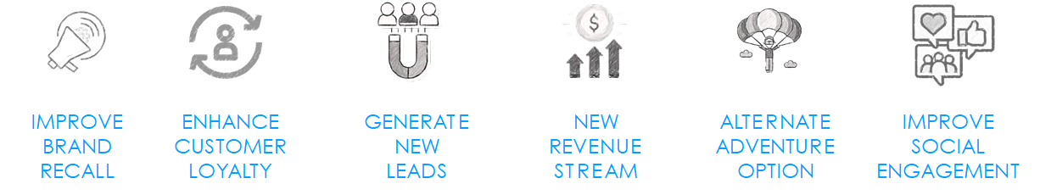

**Task:**

Assuming that you are the Product lead on this engagement, come up with a detailed deck covering following aspects:

* What should be the overarching approach to first define the problem and size of the business case? Focus only on the US power sports market right now (Hint: Research the US power sports industry, look at the competitor market shares and assess the subscription market size)
* If you were to define the overall Business Operating Model for the entire subscription value chain including the front stage and back stage operations, how would you go about creating one? Show an illustrative operating model for a subscription business
* Help the client define subscription Go-to-Market offerings including illustrative Subscription tier definitions, Vehicle access and entitlements, Delivery / pick-up options, Reservation business rules, Usage days monitoring, Cancellation policies, Booking change policies and Late return / no-show policies (Hint: Look at other OEMs who have dabbled with subscription offerings in automotive industry)
* What will be your go-to market approach to introduce the new business model as well as the platform? How would you decide on where to launch and what aspects would you consider?
* How would you go about translating the overall business objectives into a Subscription Platform product vision, roadmap and help the client in leveraging test-and-learn approach to piloting the product and how would you go about MVP definition (Hint: Think about typical consumer personas, their journeys, colleague journeys, approach with service design mindset)
* To build and scale the product, come up with an agile delivery approach and elaborate all the aspects of agile delivery including processes, ceremonies, POD structure and roles and responsibilities.